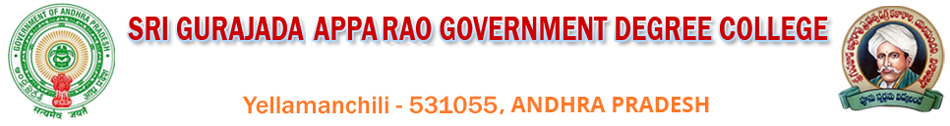
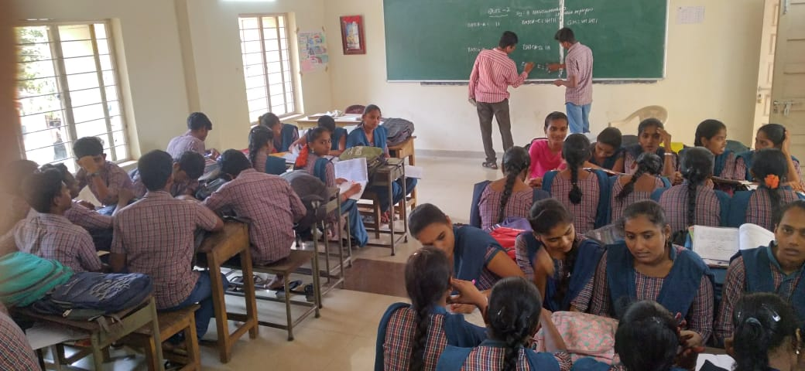
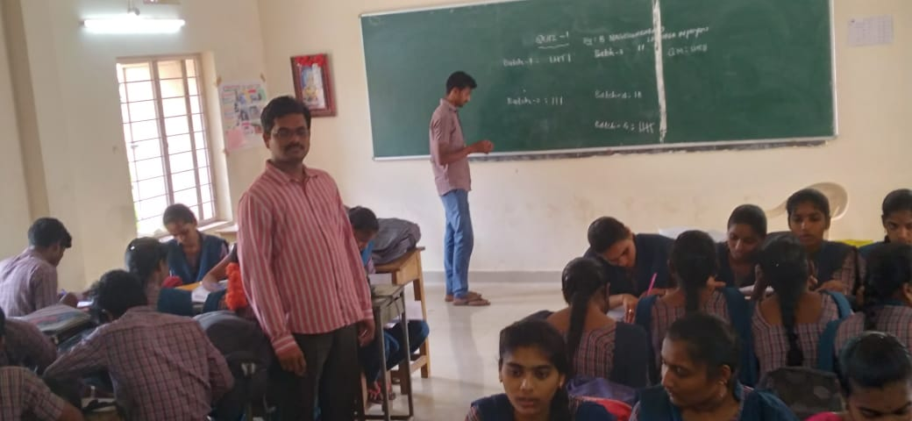 STUDENT QUIZ CONDUCTED ON 06-11-2020

Signature of HOD Signature of the Principal

